**How is the body involved in the practice of mathematics?**

**Soran Malaie**

**Introduction**

The rich tapestry of mathematical exploration weaves together the abstract and the concrete, creating a symbiotic relationship between the ethereal realm of ideas and the tangible world of physical gestures and inscriptions. The dance of mathematicians, immersed in the act of discovery, extends beyond the confines of theoretical spaces into the embodied choreography of chalk meeting board. This dynamic interaction of mind and body, as demonstrated by scholars such as Barany & MacKenzie (2014) and Marghetis et al. (2019), underscores the palpable nature of mathematical reasoning.

Delving into the heart of this intricate interplay, our study directs its gaze towards the very stage where mathematicians perform their intellectual ballet—the blackboard. The blackboard, an unassuming canvas, transforms into a dynamic arena where mathematicians engage with the physicality of their craft. Johansen & Misfeldt's (2020) video corpus becomes our lens into this captivating world, capturing the essence of mathematical creation through the fluid strokes of chalk on the board. Our methodology, an amalgamation of qualitative and quantitative analyses, aims to decipher the subtle dialogues between the mathematician's body and the mathematical conjectures they confront.

Building upon the foundation laid by previous research (Barany & MacKenzie, 2014; Greiffenhagen, 2014; Marghetis, Samson, & Landy, 2019), our exploration extends beyond the theoretical framework into the realm of tangible tools. The chalk, a seemingly mundane instrument, emerges as a key player in the cognitive toolkit of mathematicians (Weisberger, 2019). The choice of chalk brand, a subtle yet crucial decision, becomes a testament to the embodied nature of mathematical practice, revealing the intricate relationship between the mathematician and their external representations.

Visual representations on the blackboard transcend mere symbols; they become interactive agents in the problem-solving process, shaping and reshaping the narrative of mathematical discovery (Polya, 1990). The body's strategic involvement in this process becomes evident as mathematicians navigate the spatial dimensions of the blackboard, using their physicality to unravel the complexity of mathematical challenges.

Amidst the strokes of chalk and the spatial ballet on the blackboard, the act of gesturing emerges as a silent but powerful language in the discourse of mathematical reasoning. Whether through the guidance of Edwards (2009), the observations of Perry, Church, & Goldin-Meadow (1988), or the insights of Nunez (2006) and Marghetis & Nunez (2013), gestures become a bridge between the abstract and the concrete. Novices and experts alike, through movements and shapes, articulate abstract concepts, creating a dynamic dialogue between the mind, body, and mathematical ideas.

While prior investigations predominantly focused on novices or educational settings (Greiffenhagen, 2014; Nunez, 2006), our study stands as a unique exploration into the practices of mathematical experts within a naturalistic context. The video corpus, equipped with advanced measurement instruments, serves as a technological vantage point, allowing us to scrutinize the intricate interactions of different body parts during problem-solving—an endeavor that contributes to a deeper understanding of "creativity in the wild."

In the current study, the video corpus becomes our treasure trove, capturing mathematicians in solitary pursuit. Our focus narrows to two dimensions of bodily activity: writing and movement. Through meticulous examination, we aim to discern patterns in the creation of inscriptions and the spatial movements relative to the blackboard. This granular approach allows us to uncover the nuanced ways in which mathematicians deploy their bodies during the various phases of creative reasoning.

Acknowledging the foundation laid by existing knowledge, we embark on this journey not merely to reiterate well-established facts but to unveil subtleties within expert practices. Our study transcends the conventional understanding of bodily engagement, offering insights that stretch beyond the confines of mere gestures. By peering into the intricacies of mathematicians' embodied cognition, we aspire to provide a comprehensive understanding of how the body becomes an instrument in the symphony of creative reasoning.

In recognizing the potential impact of our work, we extend an invitation to the broader community interested in mathematical cognition. The implications of our findings reach beyond academia, with potential applications in educational contexts and beyond. With the utmost respect for the subjects of our study and a commitment to ethical and meaningful contributions, we set sail on this investigation to unravel the mysteries of embodied and embedded cognition in the realm of mathematics.

Our central hypothesis, akin to a guiding star, posits that mathematicians spend more time in close proximity to the board in the early stages of a session and gradually move farther away as the session progresses. This hypothesis serves as a specific focus for our empirical exploration, a compass directing our endeavors to unveil the intricate choreography of the mathematician's body in the pursuit of mathematical creativity.

**Method**

*Participants*

The participants in this study consisted of Ph.D.-level mathematicians whose interactions were captured in a video corpus compiled by Marghetis et al. (2019). The original corpus, totaling 4 hours and 40 minutes, showcased mathematical experts engaging in the process of generating proofs for mathematical conjectures. The mathematicians worked at blackboards in their personal offices or seminar rooms within their respective mathematics departments. The demographic information of the participants, including age, gender, and level of expertise, was not available for the current analysis.

*Procedure*

The study utilized the video corpus compiled by Marghetis et al. (2019) as the primary source of data. Mathematicians within the videos were tasked with formulating proofs for up to three mathematical conjectures sourced from the William Lowell Putnam Mathematics Competition. For this analysis, a specific subset of the video corpus was selected, focusing on a singular mathematician engaged in proving two conjectures during a session lasting 1 hour and 5 minutes.

*Data Collection*

To capture the spatiotemporal dynamics of the mathematicians' body movements, the study employed machine learning techniques. Specifically, the Mediapipe Pose Landmarker in Python was utilized to track the three-dimensional coordinates (x, y, and z) of specific body parts, including shoulders, elbows, wrists, and fingers. The Landmarker tracked these body parts at a frequency of 30 times per second, providing high-frequency data for analysis. Additional coding was implemented to capture movement around the room and hand gestures, enriching the dataset.

The primary focus of the data collection was on the mathematicians' body interactions with the chalkboard, with a particular emphasis on the three-dimensional coordinates of relevant body parts during different phases of the mathematical problem-solving process.

Analysis

The collected spatiotemporal data underwent an analysis to test the hypothesis that mathematicians spend more time standing close to the board earlier in the session and more time farther from the board as the session progresses. The analysis here is based solely on descriptive statistics to characterize general trends in body movements to assess the significance of observed patterns.

The original investigation by Marghetis et al. (2019) sought to explore "creativity in the wild" by delving into the problem-solving dynamics of expert mathematicians. In contrast to the original hand-coded assessments, the current project employed machine learning techniques, specifically the Mediapipe Pose Landmarker, to provide detailed spatiotemporal results in three dimensions for various body parts. This advancement facilitated a more comprehensive analysis of body part interactions during the process of mathematical problem-solving. Here, however, I only focus on right shoulder and right wrist. The infrastructure for the study included video recording equipment, data storage devices, body pose estimation using machine learning algorithms, and Python-based video analysis software.

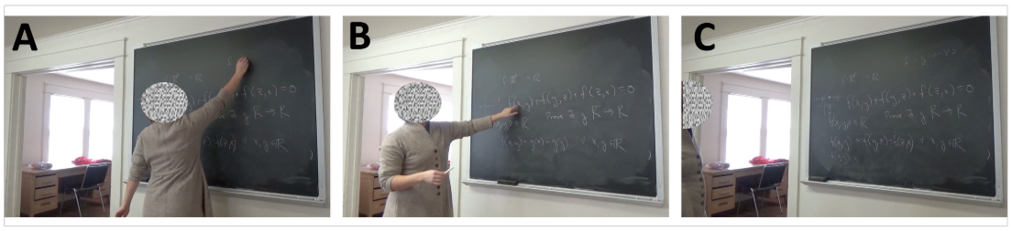

Figure . While copiously writing and gesturing, mathematicians moved from within writing distance (A), to medium distance where writing is difficult but pointing is easy (B), to a far distance where they could see the entire blackboard (C). [Tabatabeian, et al., 2023]

**Results**

In this study, due to the immense scale of the dataset, a detailed analysis was not conducted, and the focus was primarily on visualizations based on descriptive statistics. The ongoing nature of the project, in collaboration with the advisor, necessitated an initial exploration through visual representations.

The primary challenge lies in tracking various body parts, prompting an investigation into the confidence of the machine algorithm in accurately tracking the movements of the mathematician. For instance, an examination of the right wrist visibility revealed a consistently messy pattern well below a confidence threshold of 1 throughout the session, rendering it an unreliable metric.

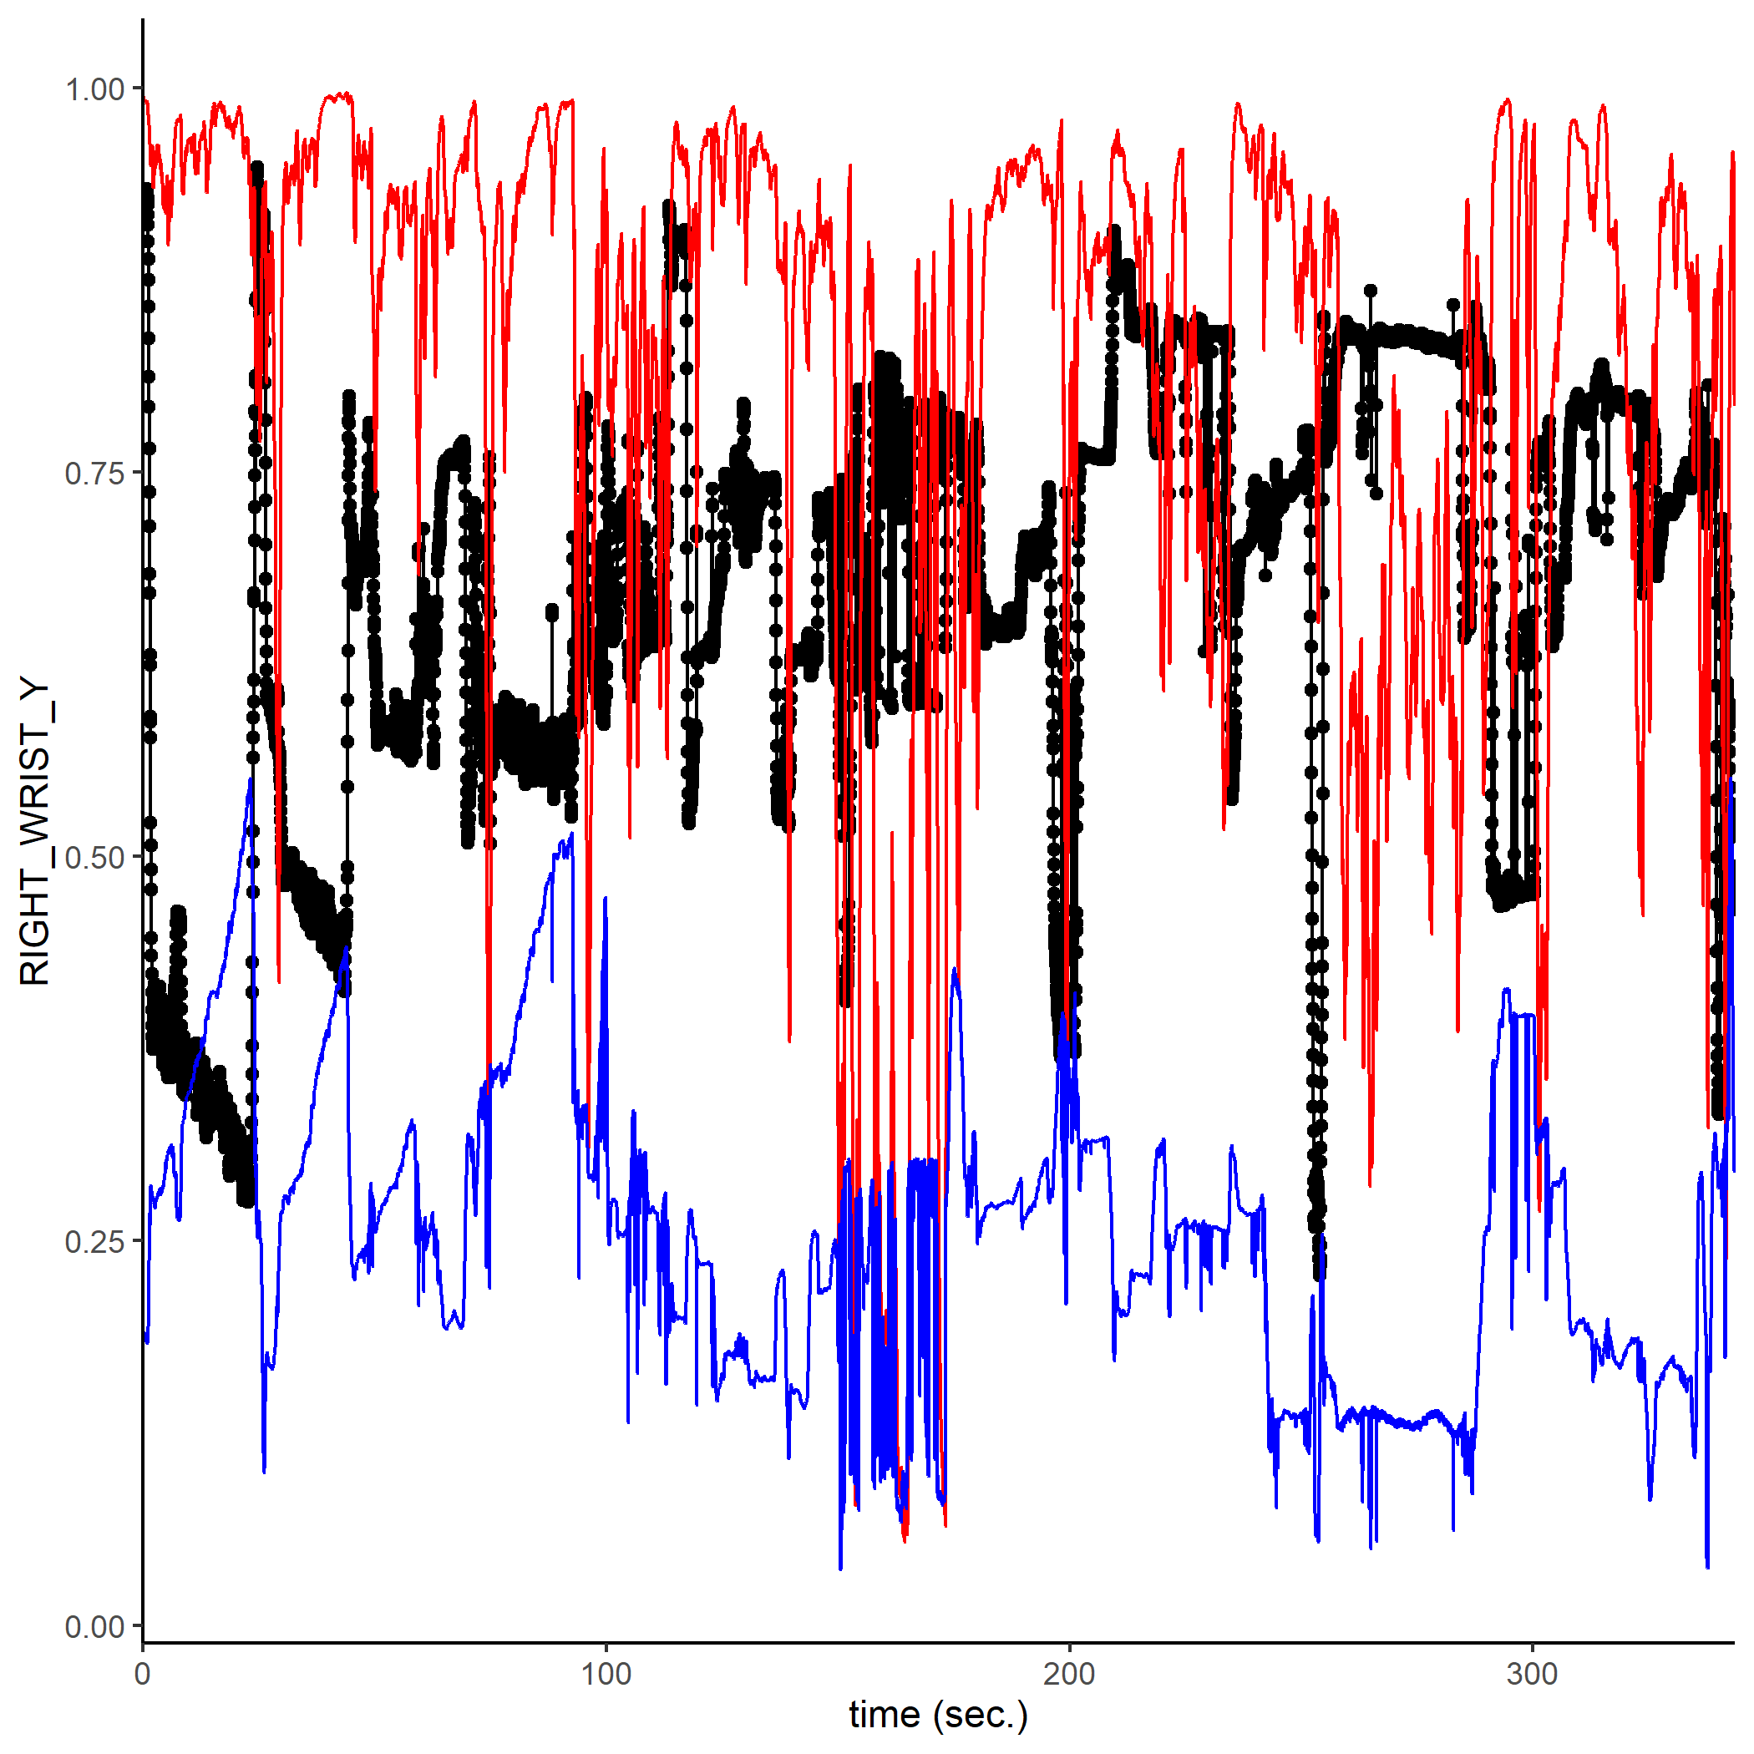

Figure . an examination of the right wrist visibility revealed a consistently messy pattern well below a confidence threshold of 1 throughout the session, rendering it an unreliable metric.

In contrast, the analysis of the right shoulder demonstrated a high level of confidence in the machine algorithm's ability to track its motions consistently over the entire session. Consequently, the right shoulder was selected as the basis for distance visualization.

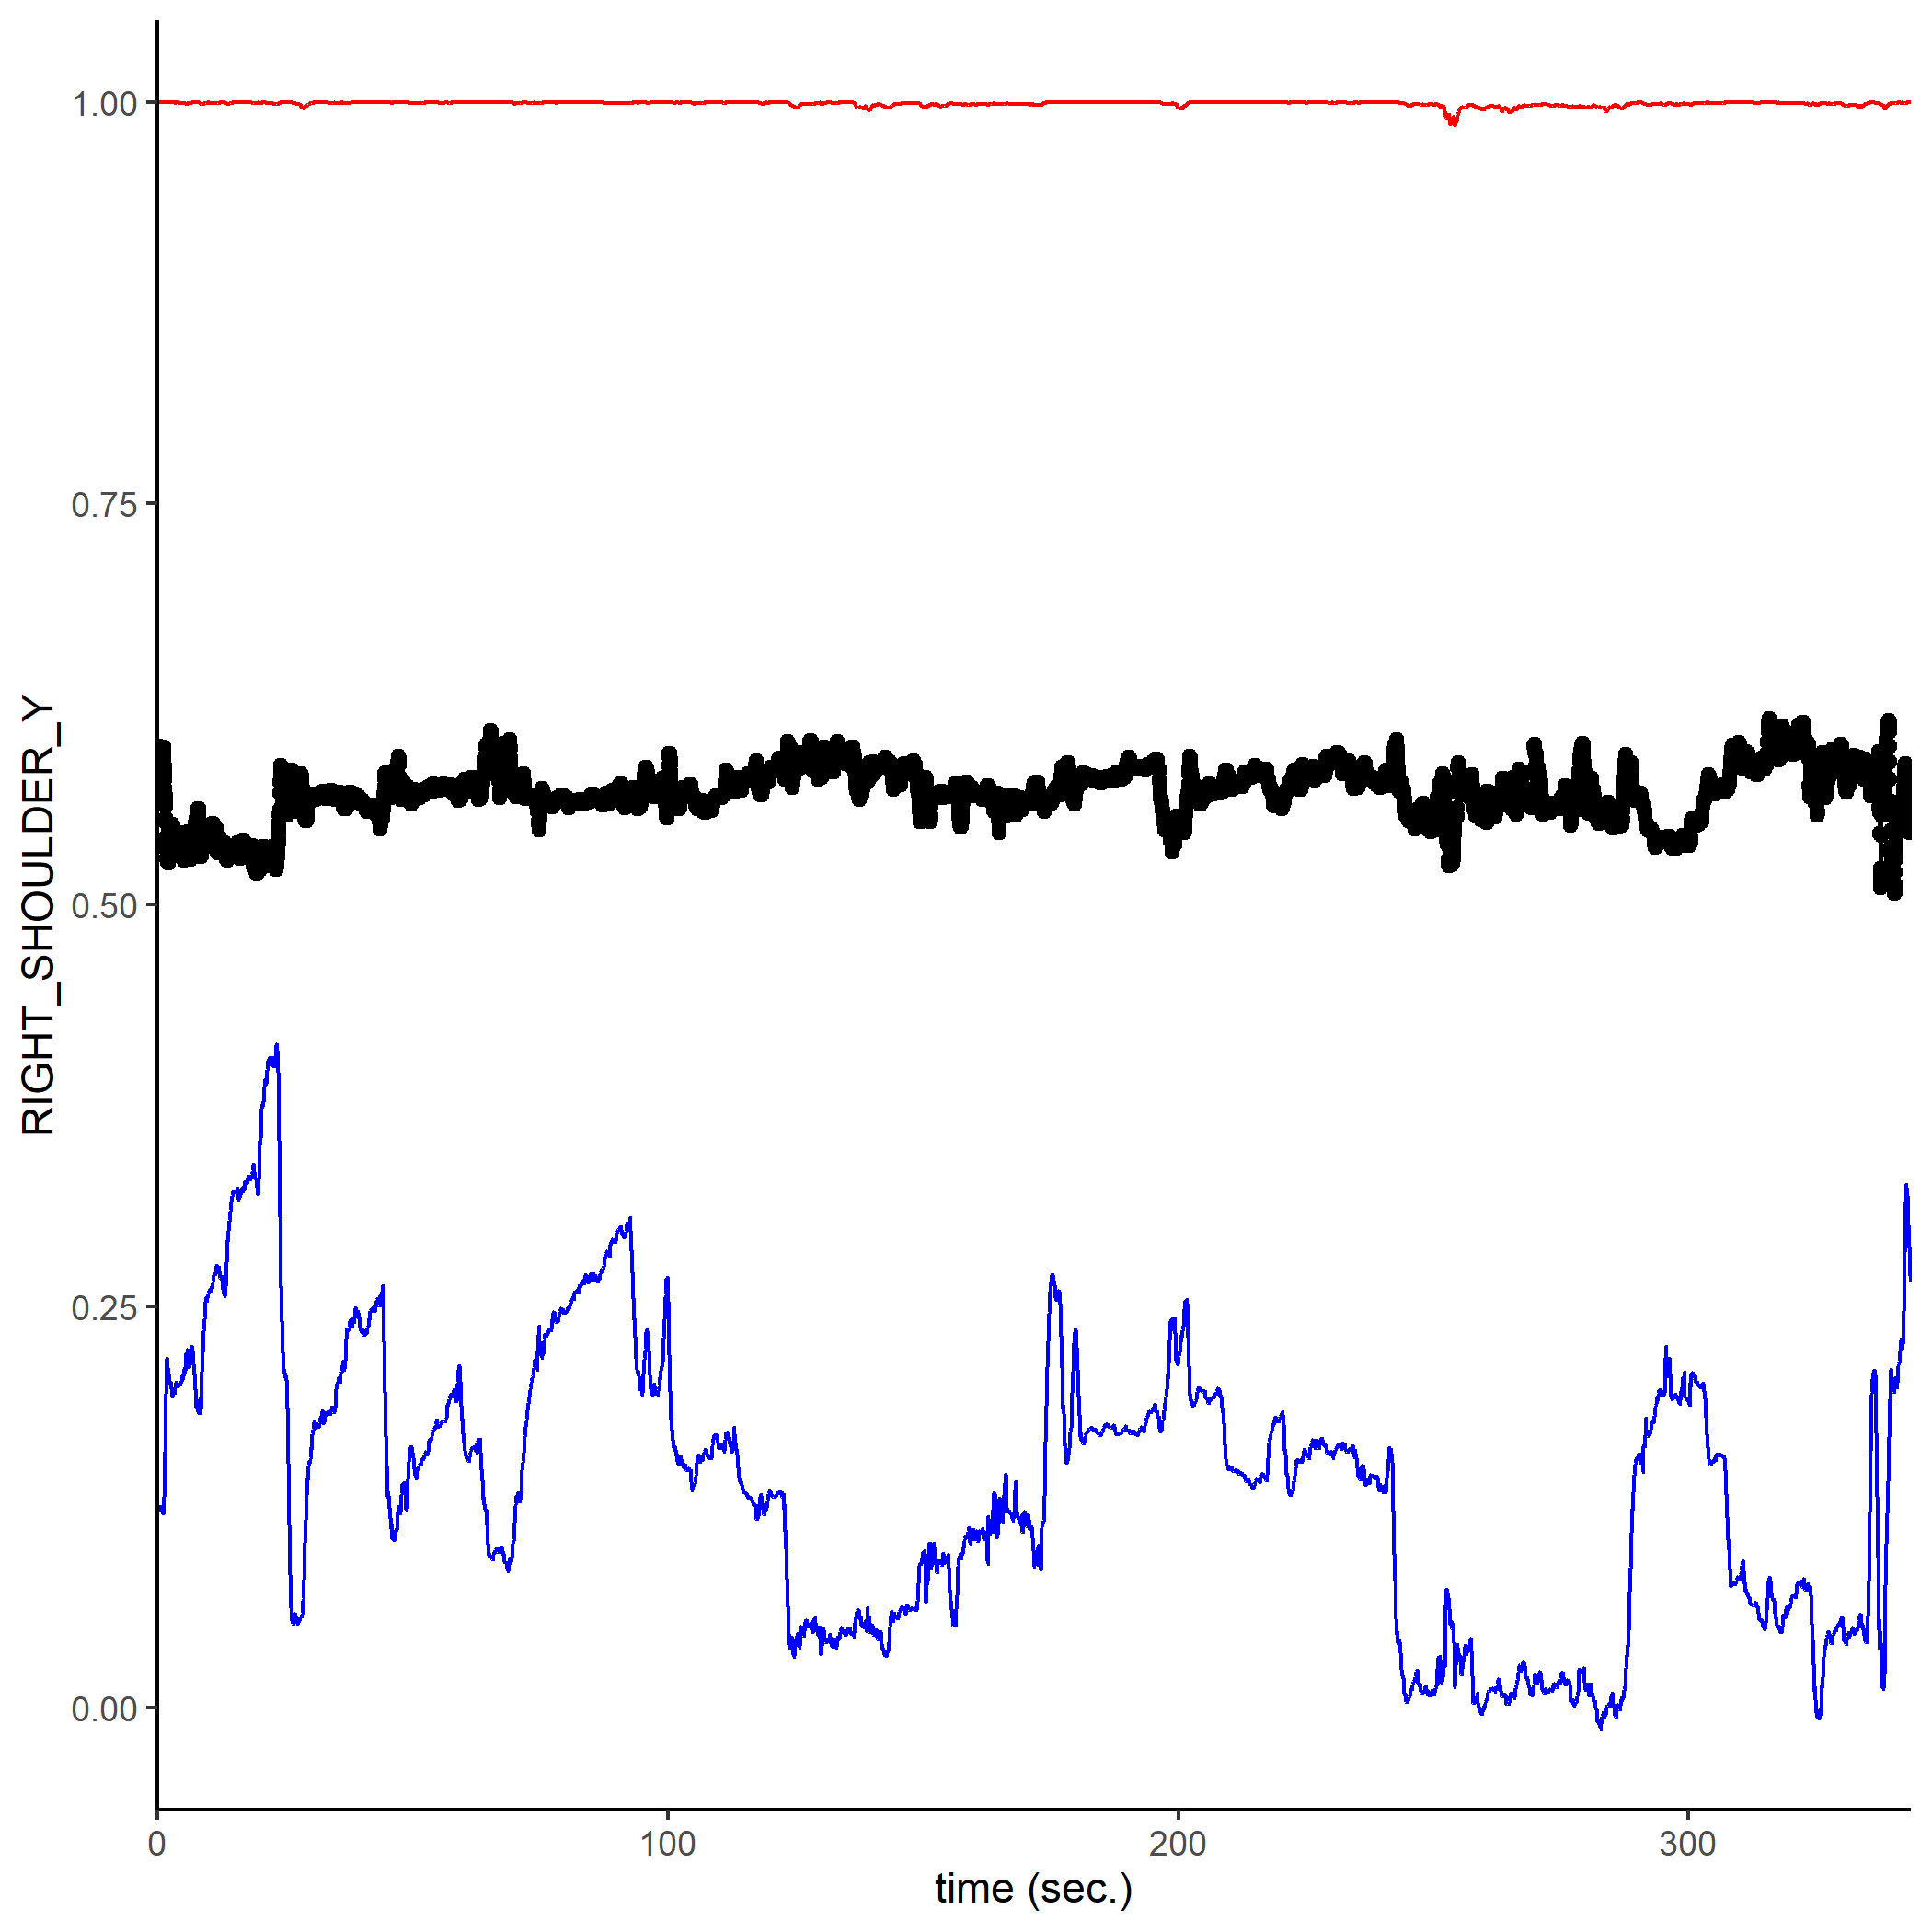

Figure . The analysis of the right shoulder demonstrated a high level of confidence in the machine algorithm's ability to track its motions consistently over the entire session.

Building upon the methodology employed by Tabatabaeian et al. (2023), the temporal aspect was divided into six timeslots. Numerical distances were then classified into three categories: close, medium, and far. The mathematician engaged in extensive writing, frequently covering the entire blackboard. The process involved a front-loaded approach, with the majority of inscriptions being generated during the initial third of the session. The substantial task of populating the blackboard primarily took place at the beginning of mathematician's endeavors. The following plot suggests a trend aligning with the initial hypothesis, indicating that mathematicians tend to spend a significant portion of their time in close proximity to the board during the early stages of the session. As the session progresses, there appears to be an inclination towards spending more time farther from the board. However, it is essential to emphasize that these observations have not yet yielded conclusive results. Further analysis and refinement are necessary to draw robust conclusions from this ongoing project.

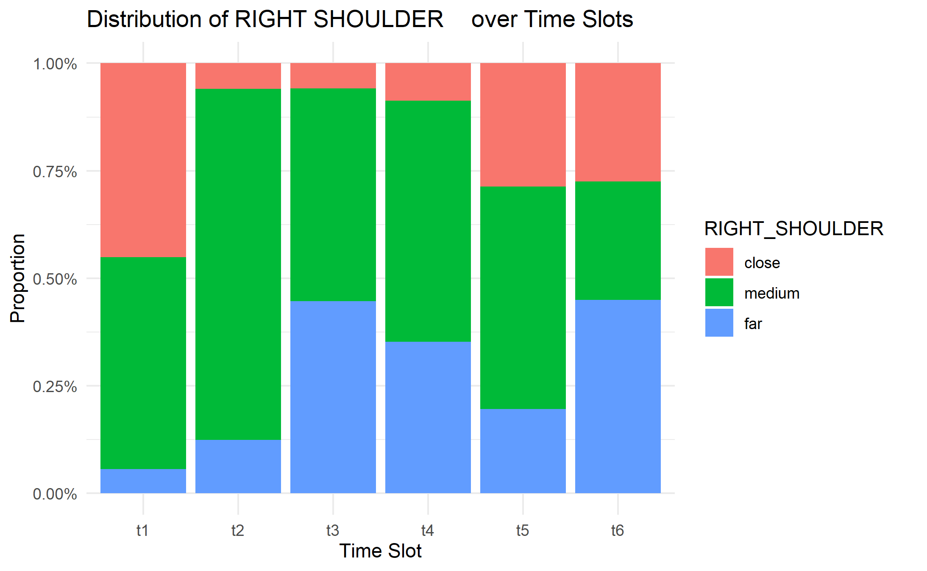

Figure . As the session progresses, there appears to be an inclination towards spending more time farther from the board.

**Discussion**

The results of our study provide valuable insights into the intricate relationship between mathematicians' physical engagement and their intellectual processes during mathematical activities. The utilization of a large-scale dataset enabled a comprehensive examination of the spatial and temporal dynamics involved in this complex interplay. In this discussion section, we delve into the implications of our findings and contextualize them within the broader landscape of studies on mathematical practice.

Our descriptive analysis shows that mathematicians, in the course of their work, are actively and dynamically engaged with the physical environment, particularly the blackboard. The generation of inscriptions through gestures, speech, and gaze underscores the multimodal nature of mathematical practice. The observed patterns of movement, characterized by mathematicians frequently stepping away from and returning to the blackboard, highlight the dynamic and iterative nature of their interactions with mathematical content.

The temporal patterns identified in our study contribute to a nuanced understanding of the sequence of activities in a mathematician's session. The front-loaded creation of inscriptions, concentrated in the initial stages, suggests a deliberate and focused effort at the onset of the session. This finding aligns with prior studies emphasizing the importance of the initial stages of problem-solving and idea generation (Csikszentmihalyi & Sawyer, 2014). The gradual shift towards spending more time farther from the board as the session progresses adds a temporal dimension to our understanding of mathematicians' work habits.

The intriguing aspect of mathematicians' movements within the room prompts a reconsideration of the role of physicality in mathematical cognition. Our proposition that these movements actively manipulate visual information challenges the traditional view of mathematicians' physical actions as mere transitions between cognitive states. The observed adjustments in distance from the board may serve a cognitive function, facilitating the discovery of unexpected connections and fostering creative insight.

The concept of inscriptions as external artifacts, as highlighted in previous literature (Johansen & Misfeldt, 2020; Greiffenhagen, 2014), takes on a renewed significance in light of our findings. The abundance of inscriptions, far from being a mere communicative act, appears to be an integral part of the creative process. Inscriptions act as tangible manifestations of inner thoughts, enabling mathematicians to externalize, evaluate, and refine their understanding. This aligns with the notion that external representations play a crucial role in problem-solving and knowledge construction (Larkin & Simon, 1987).

The observed tendency of mathematicians to gaze intently at inscriptions while away from the board suggests a strategic use of spatial distance to facilitate cognitive processes. This aligns with the idea that spatial arrangement can influence cognitive processes, as demonstrated in studies on embodied cognition (Barsalou, 2008). Mathematicians, in deliberately altering their distance from the board, may be enhancing their ability to discern hidden connections and extract information.

While our study provides valuable insights, it is essential to acknowledge its limitations. The ongoing nature of the project and the reliance on visualizations based on descriptive statistics preclude a detailed analysis of the dataset. The need for further analysis and refinement is underscored, and the current observations should be considered preliminary.

In conclusion, our study contributes to the growing body of research on mathematical practice by shedding light on the embodied and spatial dimensions of mathematicians' activities. The intricate interplay between physical engagement and cognitive processes opens avenues for future research, inviting a more nuanced understanding of how mathematicians leverage their bodily movements in the pursuit of creative insight and problem-solving.

References

Barany, M. J., & MacKenzie, D. (2014). Chalk: Materials and concepts in mathematics research. Representation in scientific practice revisited, 107.

Marghetis, T., Attari, S. Z., & Landy, D. (2019). Simple interventions can correct misperceptions of home energy use. Nature Energy, 4(10), 874-881.

Johansen, M. W., & Misfeldt, M. (2020). Material representations in mathematical research practice. Synthese, 197(9), 3721-3741.

Greiffenhagen, C. (2014). The materiality of mathematics: Presenting mathematics at the blackboard. The British journal of sociology, 65(3), 502-528.

Marghetis, T., Samson, K., & Landy, D. (2019). The complex system of mathematical creativity: Modularity, burstiness, and the network structure of how experts use inscriptions. In CogSci (Vol. 2019, pp. 763-769).

Pólya, G. (1990). Mathematics and plausible reasoning: Induction and analogy in mathematics (Vol. 1). Princeton University Press.

Edwards, J. (2009). Language and identity: An introduction. Cambridge University Press.

Perry, M., Church, R. B., & Goldin-Meadow, S. (1988). Transitional knowledge in the acquisition of concepts. Cognitive Development, 3(4), 359-400.

Marghetis, T., & Núñez, R. (2013). The motion behind the symbols: A vital role for dynamism in the conceptualization of limits and continuity in expert mathematics. Topics in cognitive science, 5(2), 299-316.

Johansen, M. W., & Misfeldt, M. (2020). Material representations in mathematical research practice. Synthese, 197(9), 3721-3741.

Larkin, J. H., & Simon, H. A. (1987). Why a diagram is (sometimes) worth ten thousand words. Cognitive science, 11(1), 65-100.

Barsalou, L. W. (2008). Grounded cognition. Annu. Rev. Psychol., 59, 617-645.

Csikszentmihalyi, M., Csikszentmihalyi, M., & Sawyer, K. (2014). Creative insight: The social dimension of a solitary moment. The systems model of creativity: The collected works of Mihaly Csikszentmihalyi, 73-98.